SAFETY ALERT
TBIT Bagroom FOD Safety
November 18, 2019

On November 18th, there was a near-miss injury due to a wooden pallet having been left beside SP17 with protruding nails. Unfortunately, a service provider working in the area stepped on the wooden pallet and on one of the nails. The nail punctured through the employees’ shoe, nearly having pierced through the employees’ skin.

All service providers are to do there do diligence in ensuring all FOD items are removed and disposed of properly prior to entering the TBIT bagroom. All FOD items pose significant safety risks, and are to be handled with extreme care to avoid injury. Images below display the dangers the FOD items pose and the amount of FOD which is accumulated daily.
NOVEMBER 18, 2019 INCIDENT:
- Wooden pallet: 2. Protruding nail:

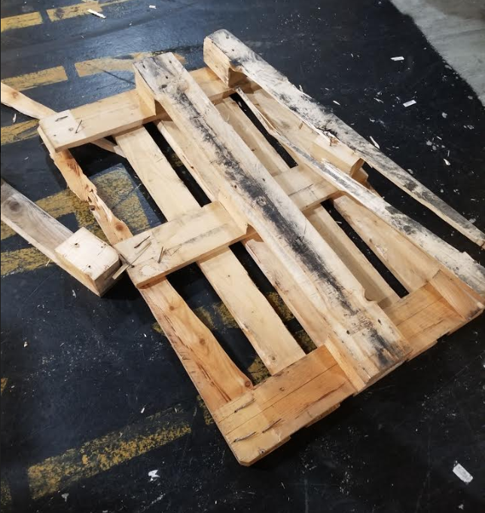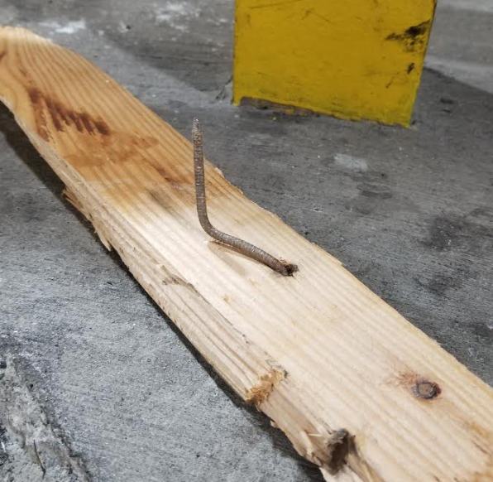

FOD:

- FOD collected throughout the TBIT bagroom.

For any queations of concerns please contact below:
TBITEC Hotline: (310) 646-9378

